**Assignment 2 COL786 (2020CH70182)**

Google Drive link: <https://drive.google.com/drive/folders/1O6NAWMaETkOzMdFN2cGG1LR3vzScx3aG?usp=sharing>

**Part1**

Pre-processing of Structural MRI

Structural MRI → Brain Extraction → Linear Registration to Standard MNI Template

Before brain extraction:

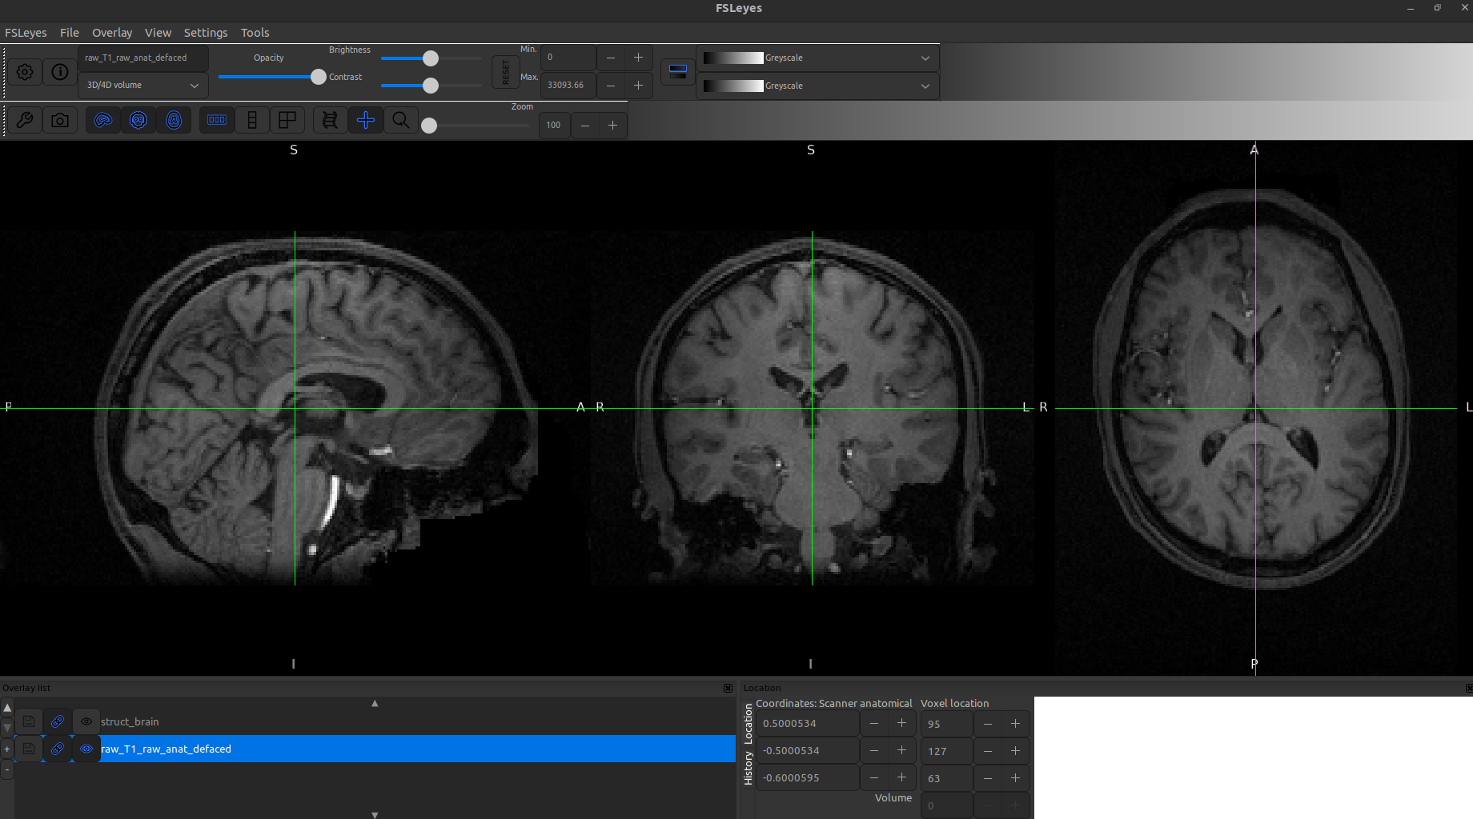

After Brain extraction:

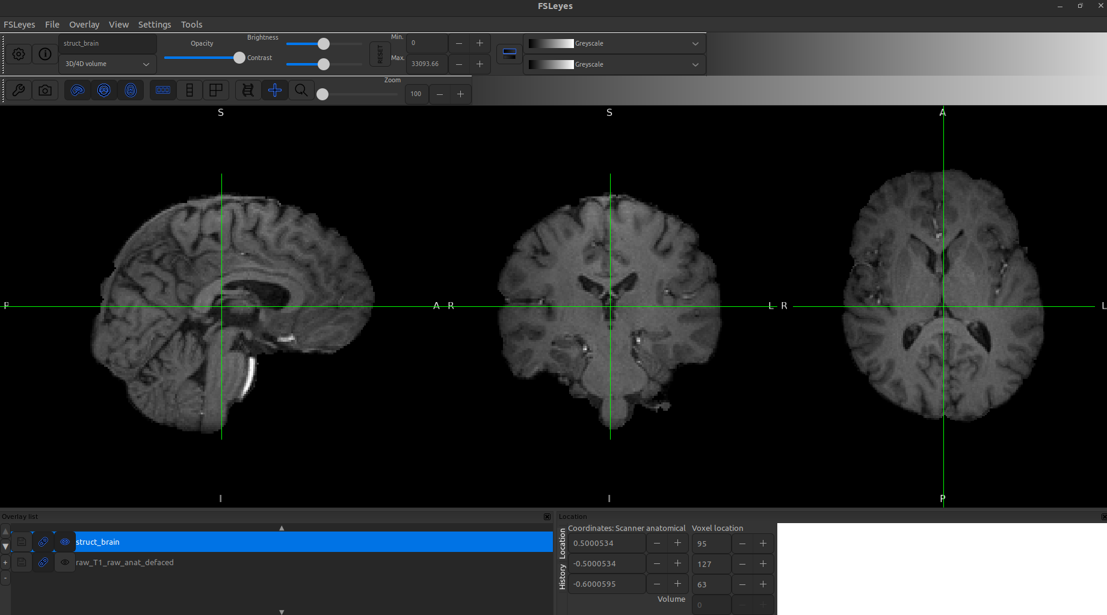

After Registration to Standard MNI Template

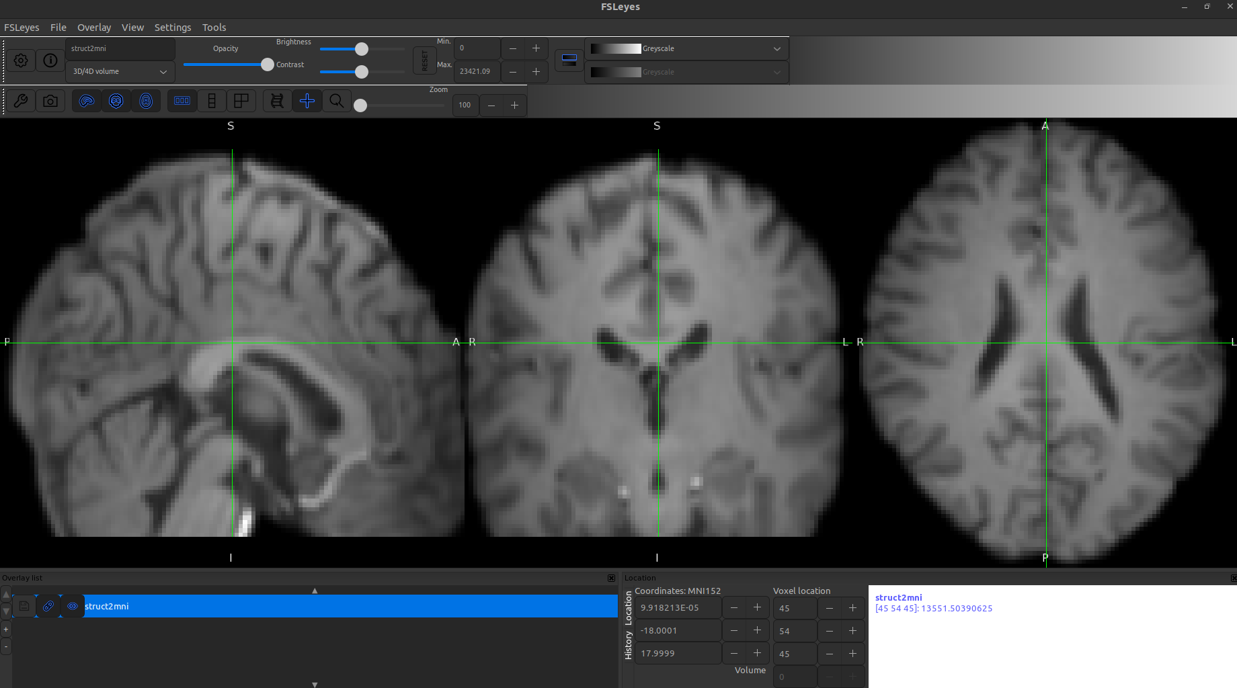

Pre-processing of Functional MRI

Functional MRI → Brain Extraction → Motion Correction → Spatial Smoothing → Temporal Filtering → Registration to Structural MRI

Feat analysis GUI

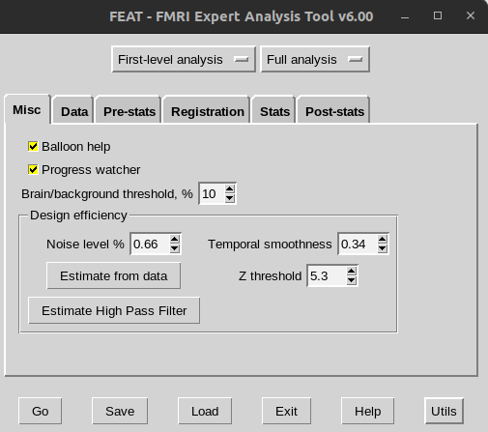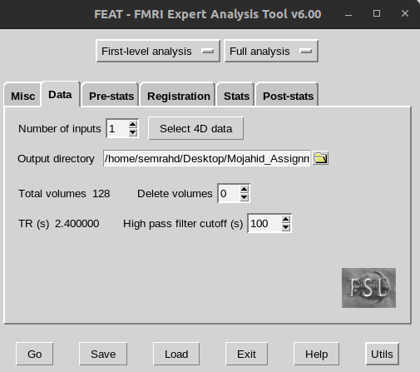

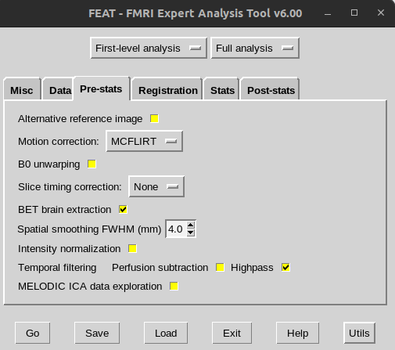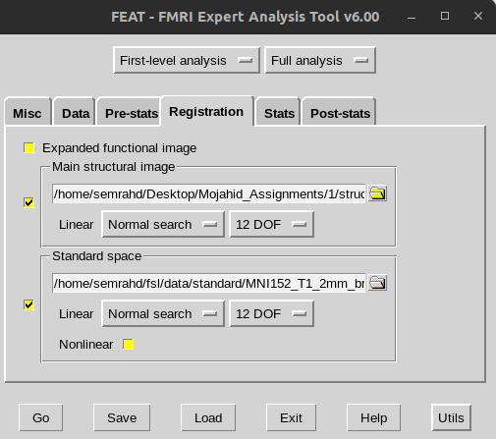

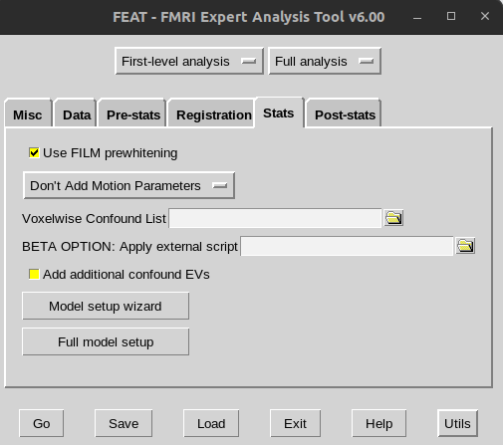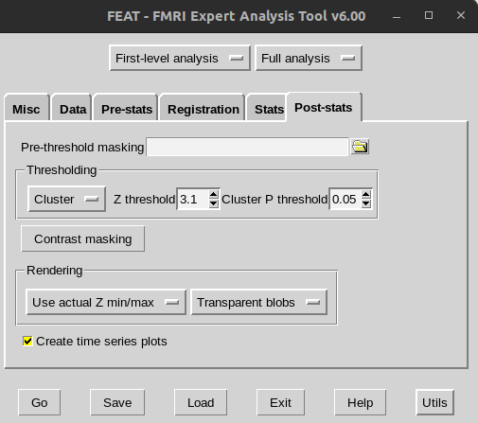

Brain extraction from functional MRI

Before:

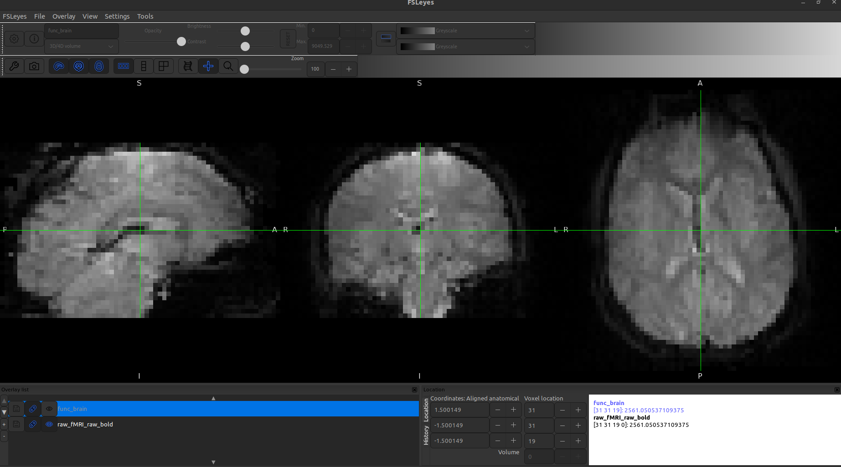

After Brain Extraction:

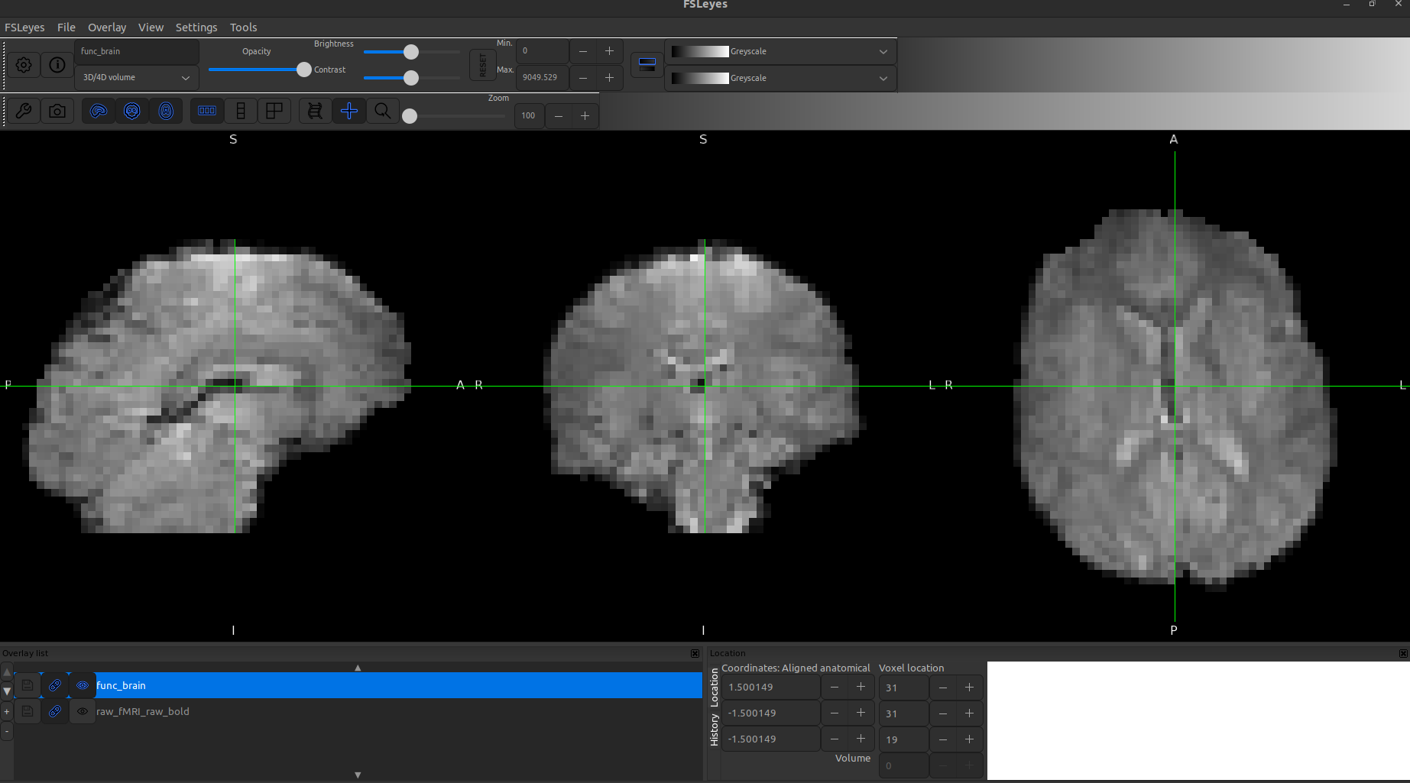

Spatial Smoothing

Before:

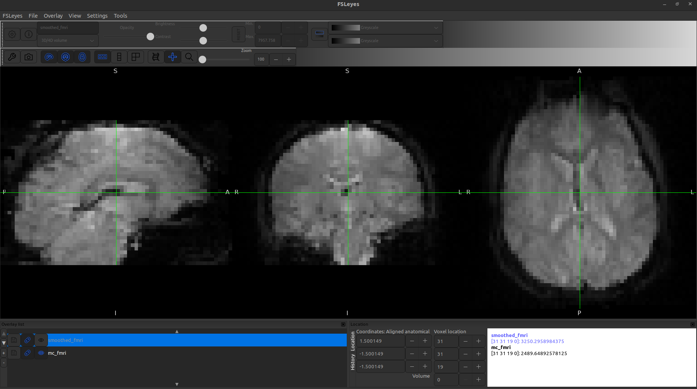

After:

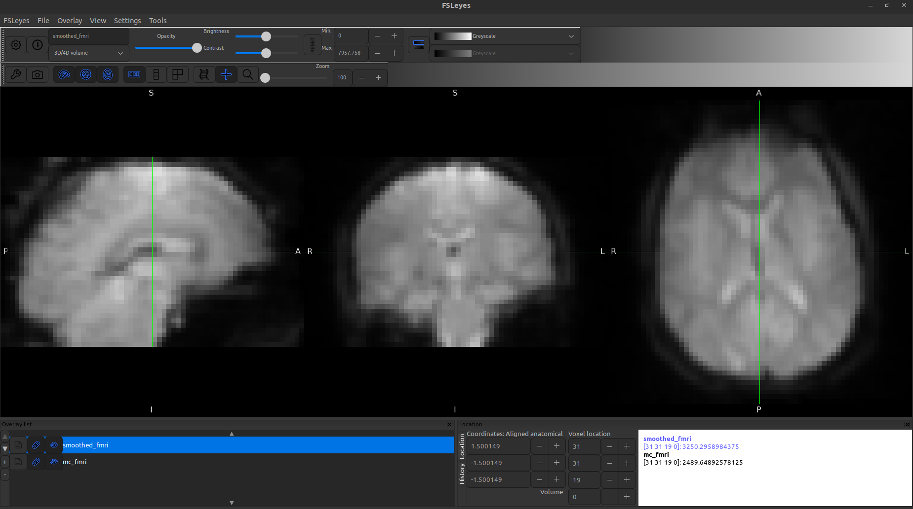

Time series of motion corrected

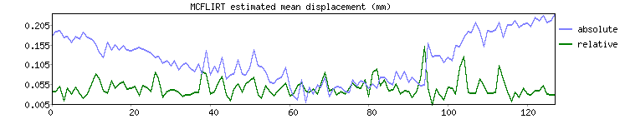

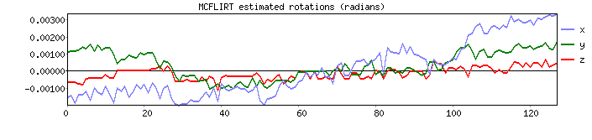

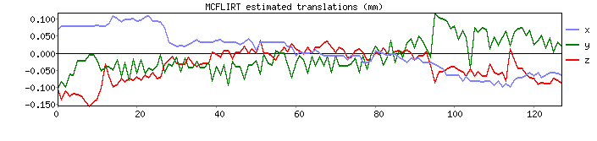

Final registration

Functional to anatomical

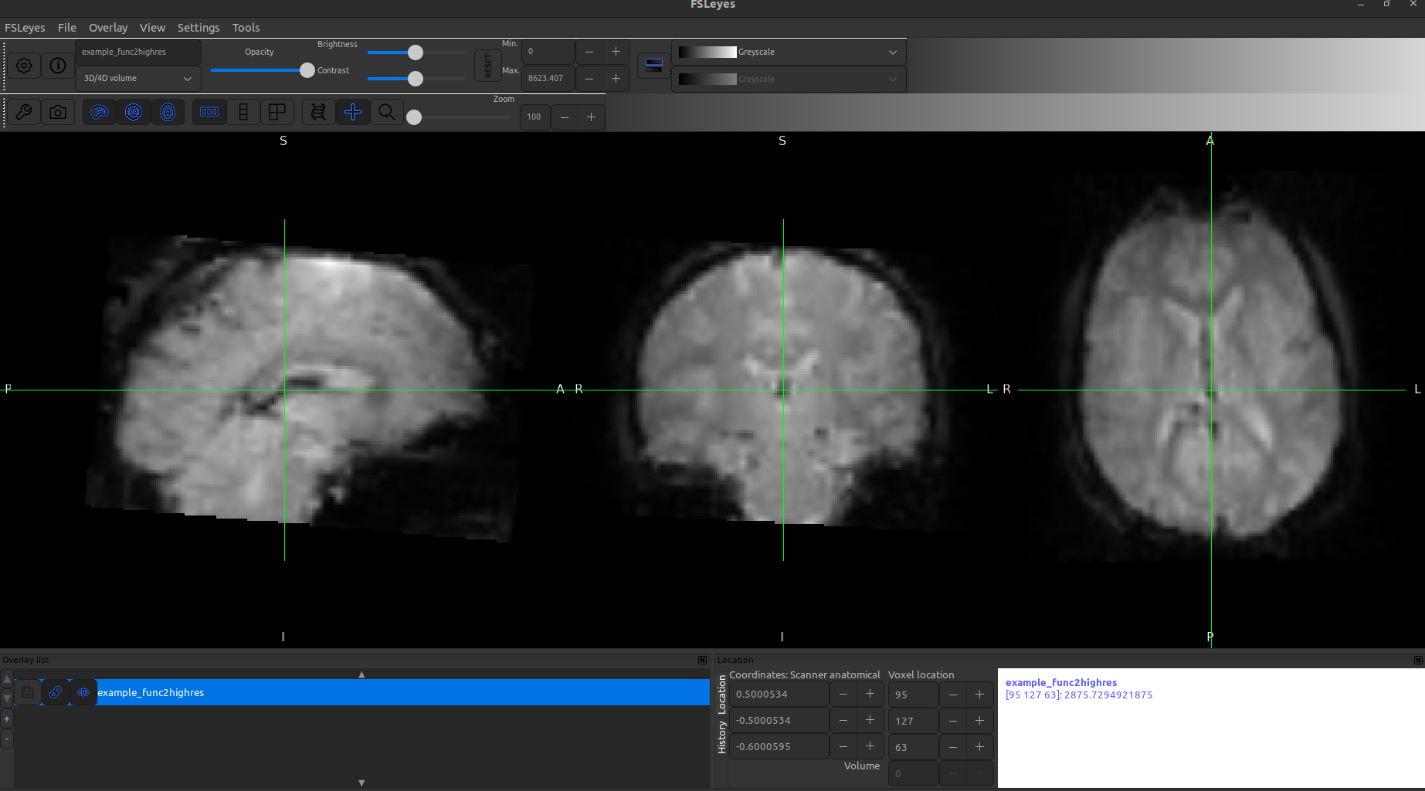

Functional to standard

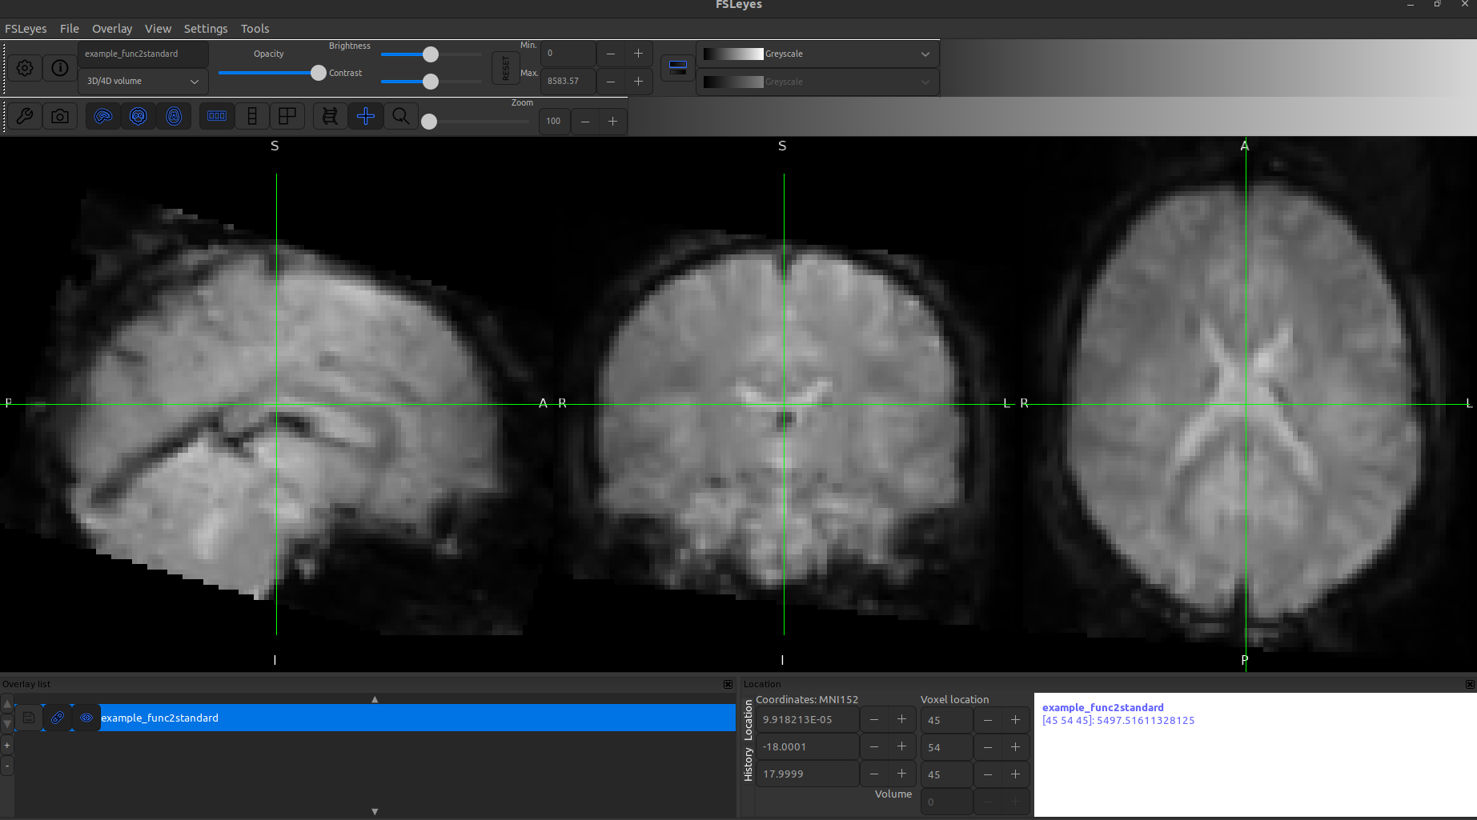

**Part 2**

Design matrix 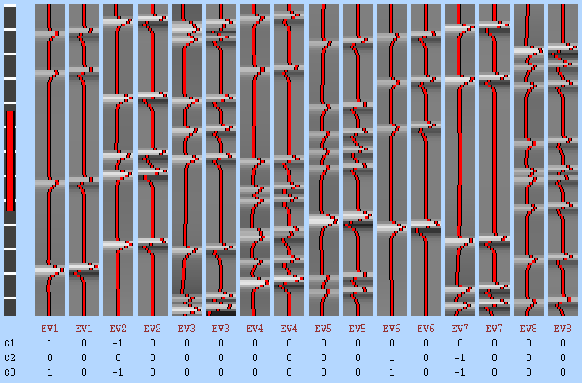

Covariance matrix & design efficiency

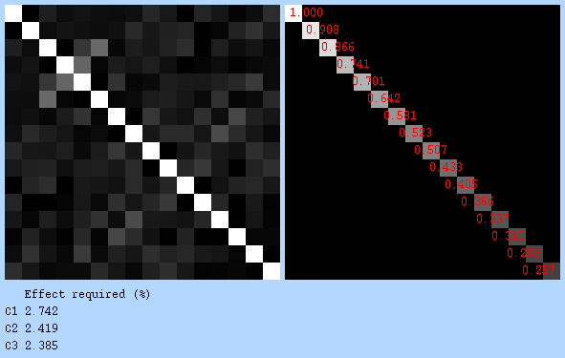

Left Hand Conjunction

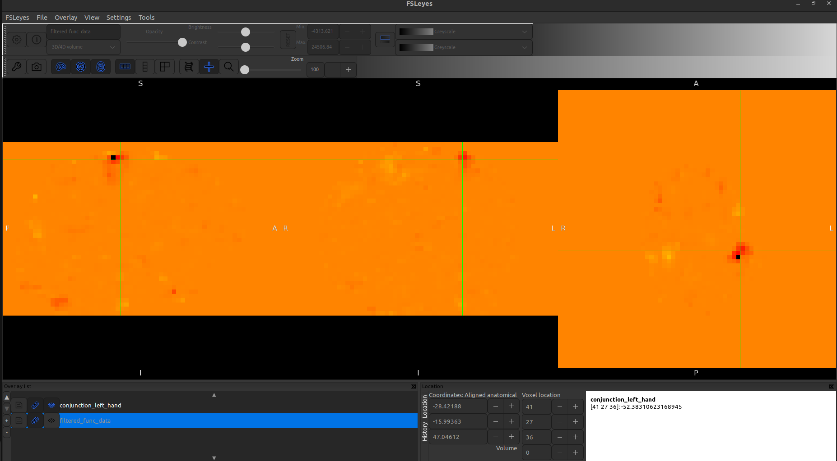

Right Hand Conjunction

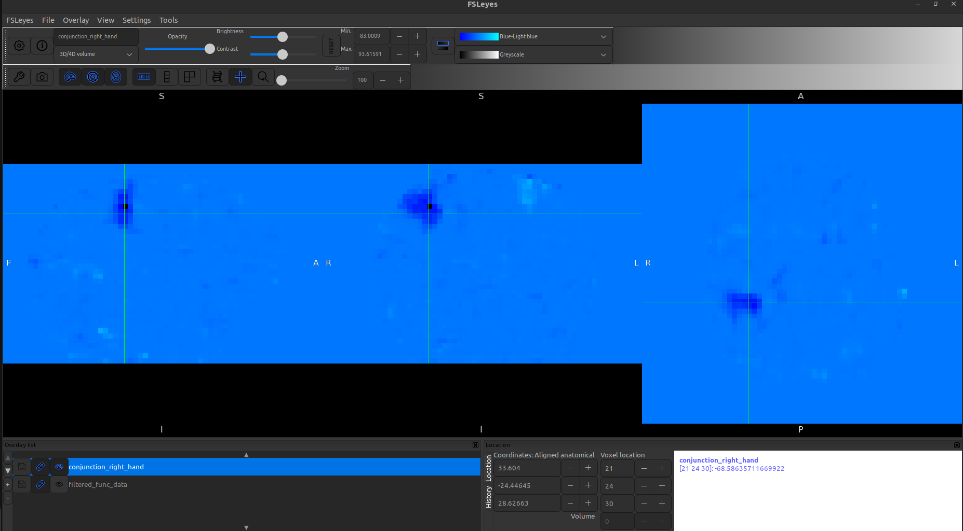

In Below image:

Brain areas selectively involved in left-hand movement (shown in red-yellow).

Brain areas selectively involved in right-hand movement (shown in blue-lightblue).

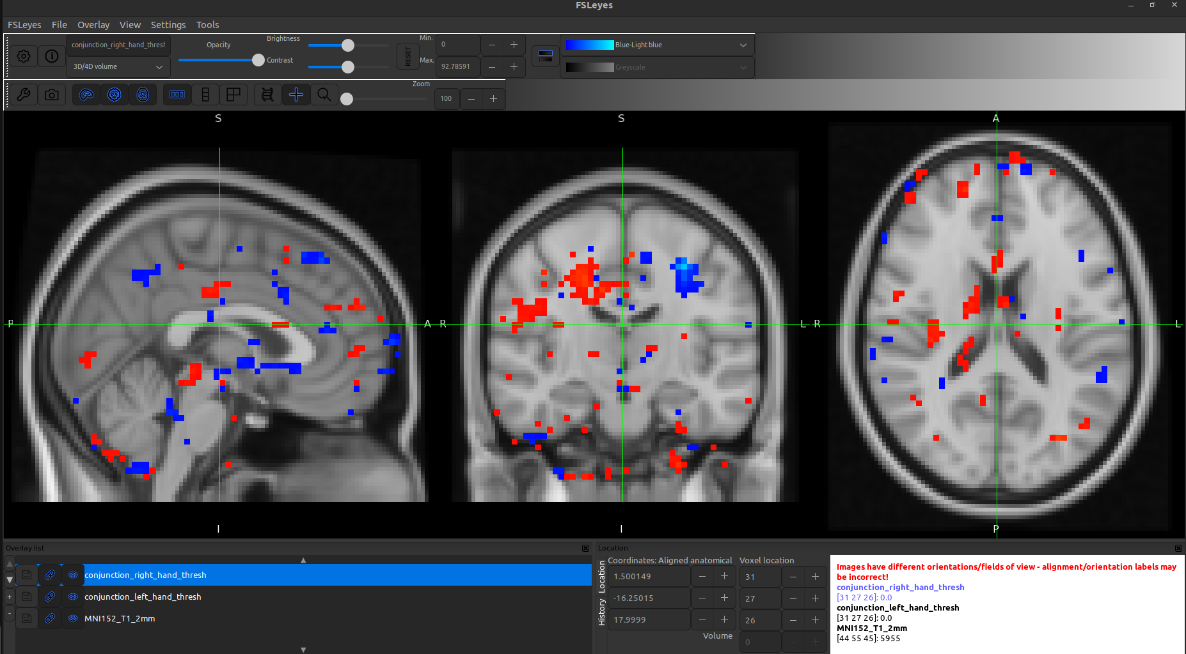

The fMRI conjunction analysis findings reveal activation patterns for left-hand and right-hand movements overlaid on the MNI152 standard template. The red clusters correspond to left-hand movement activation, while the blue clusters represent right-hand movement activation. As per neurophysiological expectations, left-hand movement should primarily activate the right hemisphere, and right-hand movement should activate the left hemisphere due to contralateral motor control.

The observed results largely align with this ground truth, as activation is predominantly found in the expected hemispheres. However, some deviations are present, including minor ipsilateral activation—where certain regions in the same hemisphere as the movement exhibit activity—which is not typical for primary motor tasks. Additionally, bilateral activation is observed in certain areas, which may indicate involvement of secondary motor regions such as the Supplementary Motor Area (SMA) or could result from motion artifacts in the fMRI preprocessing pipeline. Furthermore, the expected cerebellar activation, which should be present contralaterally, is not clearly visible in the results. These deviations might stem from factors such as a lower statistical threshold, minor misalignments in functional-to-MNI registration, or preprocessing inconsistencies.

To refine the accuracy of the findings, increasing the Z-score threshold to filter out weak activations, verifying the quality of image registration, and reviewing preprocessing steps like motion correction and smoothing could be beneficial. Despite these minor discrepancies, the overall activation patterns are consistent with known motor control mechanisms in the brain.

Deactivations

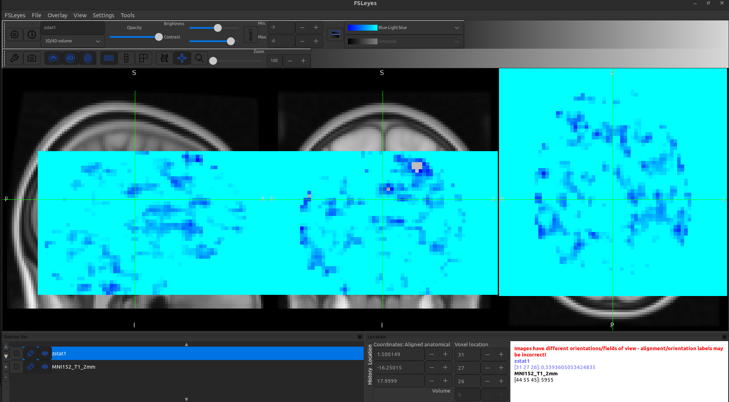

Table 01. Brain areas that are selectively involved in movement of the left hand (only those clusters included having size greater than 14).

|  |  |  |  |  |
| --- | --- | --- | --- | --- |
| Cluster’s Size | MNI X (mm) | MNI Y (mm) | MNI Z (mm) | Brain's region |
| 713 | 33 | -24 | 33 | No label found! |
| 107 | -57 | -30 | -36 | 1% Inferior Temporal Gyrus,  posterior division |
| 103 | 39 | -51 | -54 | No label found! |
| 52 | -18 | -6 | -24 | 21% Parahippocampal Gyrus,  anterior division |
| 52 | -33 | -75 | 0 | 7% Lateral Occipital Cortex, inferior  division, 3% Occipital Fusiform Gyrus |
| 44 | 27 | 30 | -15 | 67% Frontal Orbital Cortex,  20% Frontal Pole |
| 41 | 3 | -30 | -6 | No label found! |
| 40 | -33 | -81 | -24 | 9% Lateral Occipital Cortex, inferior  division, 4% Occipital Fusiform Gyrus |
| 38 | 48 | 27 | -33 | 3% Temporal Pole |
| 28 | -6 | 57 | 6 | 62% Frontal Pole, 16% Paracingulate  Gyrus, 4% Frontal Medial Cortex |
| 27 | 21 | -78 | -6 | 38% Occipital Fusiform Gyrus, 12%  Lingual Gyrus, 1% Lateral Occipital  Cortex, inferior division |
| 23 | -45 | 3 | -24 | 10% Temporal Pole, 8% Superior  Temporal Gyrus, anterior division,  3% Planum Polare, 3% Middle  Temporal Gyrus, anterior division |
| 23 | -9 | -78 | -3 | 43% Lingual Gyrus, 6% Occipital  Fusiform Gyrus, 2% Intracalcarine Cortex |
| 23 | -27 | -12 | -54 | No label found! |
| 23 | 18 | 54 | 18 | 23% Frontal Pole |
| 22 | 24 | 57 | 3 | 73% Frontal Pole |
| 22 | 12 | -81 | 3 | 46% Intracalcarine Cortex, 12%  Lingual Gyrus, 1% Occipital Pole |
| 21 | -21 | 3 | 24 | No label found! |
| 20 | -36 | -21 | -45 | No label found! |
| 20 | 15 | 54 | -12 | 5% Frontal Pole |
| 19 | 6 | -72 | -48 | No label found! |
| 18 | 48 | 3 | 33 | 47% Precentral Gyrus |
| 18 | 6 | -54 | -60 | No label found! |
| 17 | -27 | 9 | 48 | 31% Middle Frontal Gyrus, 9%  Superior Frontal Gyrus |
| 17 | 15 | -69 | -36 | No label found! |
| 17 | -12 | 12 | 30 | 7% Cingulate Gyrus, anterior  division, 1% Paracingulate Gyrus |
| 17 | 36 | 33 | -33 | No label found! |
| 16 | 9 | -57 | 15 | 61% Precuneous Cortex, 11%  Supracalcarine Cortex, 10%  Intracalcarine Cortex |
| 16 | -21 | -81 | -15 | 59% Occipital Fusiform Gyrus,  9% Lingual Gyrus, 5% Lateral  Occipital Cortex, inferior division |
| 16 | 30 | 66 | 15 | 27% Frontal Pole |
| 16 | 30 | -18 | -60 | No label found! |
| 15 | 15 | 3 | -33 | 10% Parahippocampal Gyrus,  anterior division |

Table 02. Brain areas that are selectively involved in movement of the right hand (only those clusters included having size greater than 14).

|  |  |  |  |  |
| --- | --- | --- | --- | --- |
| Cluster’s Size | MNI X | MNI Y | MNI Z | Brain's Region |
| 252 | -24 | -57 | -51 | No label found! |
| 168 | -27 | -21 | 48 | 5% Precentral Gyrus, 1% Postcentral Gyrus |
| 134 | 30 | -39 | -9 | 22% Lingual Gyrus, 14% Parahippocampal  Gyrus, posterior division, 2% Temporal  Occipital Fusiform Cortex |
| 126 | 66 | -39 | -3 | 37% Middle Temporal Gyrus, temporooccipital  part, 30% Middle Temporal Gyrus, posterior  division, 3% Superior Temporal Gyrus, posterior  division, 1% Supramarginal Gyrus, posterior division |
| 87 | 27 | 18 | 48 | 32% Middle Frontal Gyrus, 23% Superior Frontal Gyrus |
| 79 | 0 | 27 | -9 | 88% Subcallosal Cortex, 2% Paracingulate Gyrus,  1% Cingulate Gyrus, anterior division |
| 70 | -9 | 69 | -6 | 62% Frontal Pole |
| 67 | 0 | 36 | 51 | 31% Superior Frontal Gyrus |
| 60 | -6 | -75 | -45 | No label found! |
| 48 | -3 | 9 | 42 | 43% Paracingulate Gyrus, 40% Cingulate Gyrus,  anterior division, 8% Juxtapositional Lobule  Cortex (formerly Supplementary Motor Cortex) |
| 46 | 33 | -39 | -42 | No label found! |
| 45 | 60 | 9 | 21 | 45% Precentral Gyrus, 23% Inferior Frontal  Gyrus, pars opercularis |
| 44 | -63 | -42 | -18 | 37% Inferior Temporal Gyrus, posterior division,  18% Inferior Temporal Gyrus, temporooccipital  part, 18% Middle Temporal Gyrus, posterior division,  8% Middle Temporal Gyrus, temporooccipital part |
| 30 | 18 | -33 | -3 | 9% Parahippocampal Gyrus, posterior division,  5% Cingulate Gyrus, posterior division, 2% Lingual Gyrus |
| 29 | -33 | -54 | 33 | 6% Angular Gyrus, 4% Lateral Occipital Cortex,  superior division, 4% Superior Parietal Lobule,  3% Supramarginal Gyrus, posterior division |
| 27 | 39 | 3 | -48 | 28% Inferior Temporal Gyrus, anterior division,  12% Temporal Pole, 11% Temporal Fusiform Cortex,  anterior division, 3% Temporal Fusiform Cortex,  posterior division, 1% Inferior Temporal Gyrus,  posterior division |
| 26 | 6 | -54 | 42 | 85% Precuneous Cortex, 3% Cingulate Gyrus,  posterior division |
| 26 | -33 | -72 | -45 | No label found! |
| 22 | 57 | 51 | 6 | No label found! |
| 22 | -42 | 21 | 30 | 38% Middle Frontal Gyrus, 5% Inferior Frontal  Gyrus, pars triangularis, 4% Inferior Frontal Gyrus,  pars opercularis |
| 21 | 42 | 36 | -18 | 61% Frontal Pole, 21% Frontal Orbital Cortex,  1% Inferior Frontal Gyrus, pars triangularis |
| 21 | -33 | 24 | 9 | 57% Frontal Operculum Cortex, 7% Inferior  Frontal Gyrus, pars triangularis, 4% Insular  Cortex, 2% Frontal Orbital Cortex |
| 20 | -12 | -69 | 30 | 43% Precuneous Cortex, 21% Cuneal Cortex,  2% Supracalcarine Cortex |
| 20 | 9 | -33 | -39 | No label found! |
| 18 | 60 | 24 | -18 | No label found! |
| 18 | 54 | 6 | -45 | 4% Inferior Temporal Gyrus, anterior division,  3% Temporal Pole, 1% Middle Temporal Gyrus,  anterior division |
| 17 | 42 | 18 | -21 | 67% Temporal Pole, 9% Frontal Orbital Cortex |
| 17 | -21 | 57 | -6 | 61% Frontal Pole |
| 16 | 48 | -15 | -42 | 29% Inferior Temporal Gyrus, posterior division,  8% Inferior Temporal Gyrus, anterior division,  3% Temporal Fusiform Cortex, posterior division,  1% Temporal Fusiform Cortex, anterior division |
| 15 | 27 | -60 | 33 | 20% Lateral Occipital Cortex, superior division,  2% Precuneous Cortex, 2% Angular Gyrus,  1% Cuneal Cortex |
| 15 | -24 | -42 | 0 | 1% Lingual Gyrus, 1% Parahippocampal Gyrus,  posterior division |
| 15 | 45 | 57 | 15 | 2% Frontal Pole |

**Part 3**

### **Method Used: A Combination of Subtraction & Conjunction Analysis**

Reason to use it:

Subtraction Analysis helps isolate language-specific regions by comparing Language tasks (audio/video sentences) vs. non-language tasks (checkerboards, motor tasks). Conjunction Analysis finds brain areas active across multiple language tasks ensuring reliability.

Analysed two key explanatory variables (EVs) from fMRI data:

* Language Tasks:
  + *Audio Sentence*
  + *Video Sentence*
* Control Tasks (Non-Language):
  + *Horizontal Checkerboard*
  + *Vertical Checkerboard*

I created three contrasts to find language-specific activation:

1. Language - Visual Control: identifies general language processing areas.
2. Audio Sentence - Checkerboard: isolates speech comprehension (auditory).
3. Video Sentence - Checkerboard: isolates speech perception (visual).

**Intermediate results**

zstat1 - C1 (Language - Visual Control)

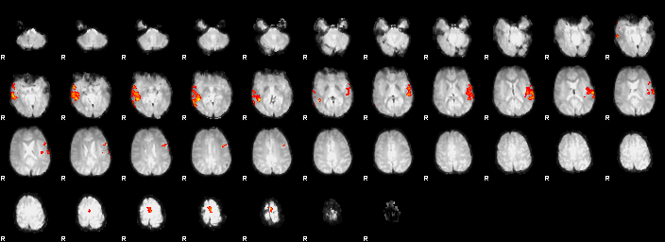

zstat2 - C2 (Audio Sentence - Checkerboard)

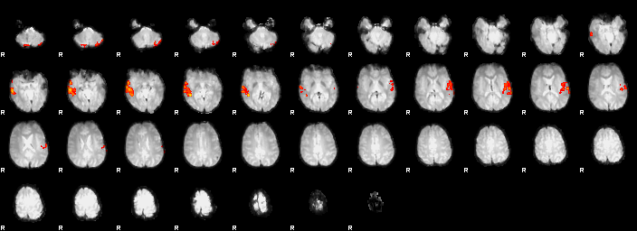

zstat3 - C3 (Video Sentence - Checkerboard)

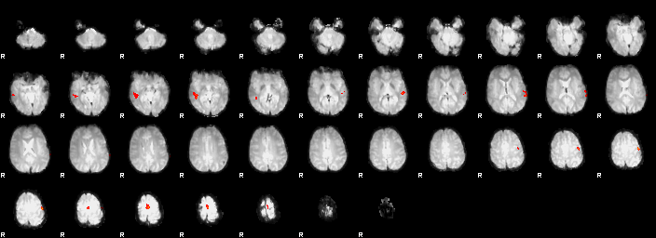

# FEAT Time Series Report - zstat1

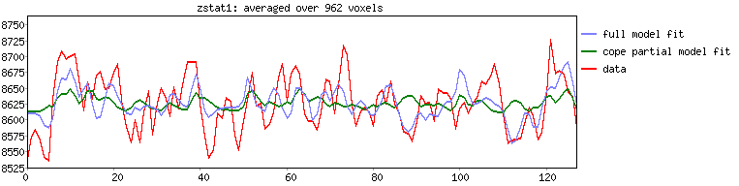

FEAT Time Series Report - zstat1

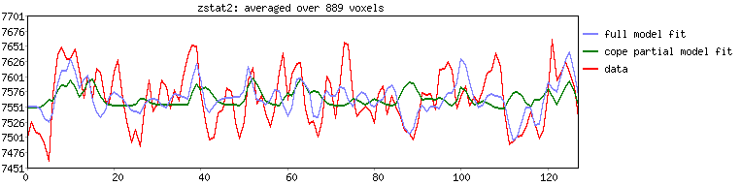FEAT Time Series Report - zstat1

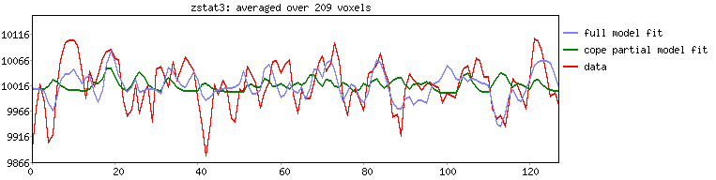

Design Matrix

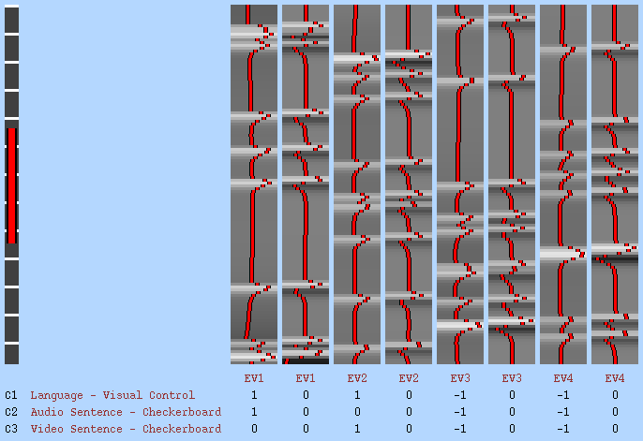

Covariance matrix & design efficiency

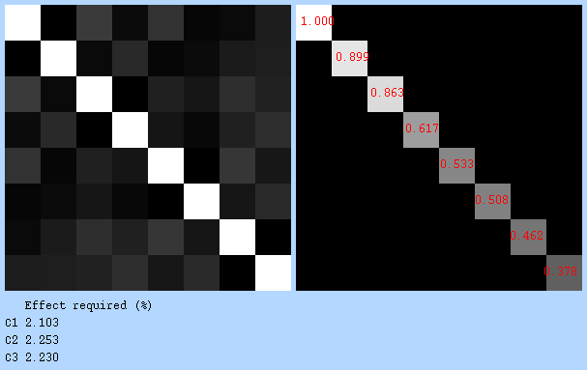

Final Result 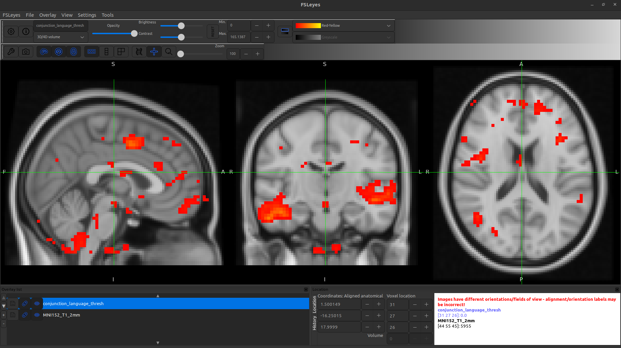

My thought on this finding:

The activation in the left inferior frontal gyrus (LIFG) aligns with Broca’s area, supporting its role in speech production and language comprehension. Similarly, left superior temporal gyrus (STG) activation matches Wernicke’s area, crucial for understanding spoken language. Some activation in the right hemisphere, particularly in frontal and temporal regions, is expected for higher-order language processing.

Table 03. Indicating clusters involved in language comprehension (only those clusters included having size greater than 9).

|  |  |  |  |  |
| --- | --- | --- | --- | --- |
| Cluster’s size | MNI X | MNI Y | MNI Z | Brain's Region |
| 2022 | -63 | -21 | -3 | 58% Superior Temporal Gyrus, posterior division, 26%  Middle Temporal Gyrus, posterior division,  2% Planum Temporale, 1% Heschl's Gyrus (includes H1 and H2),  1% Middle Temporal Gyrus, anterior division |
| 1815 | 42 | -30 | -18 | 27% Temporal Fusiform Cortex, posterior division,  23% Inferior Temporal Gyrus, posterior division,  4% Inferior Temporal Gyrus, temporooccipital part,  1% Temporal Occipital Fusiform Cortex |
| 1110 | 9 | -66 | -57 | No label found! |
| 392 | 3 | 0 | 45 | 64% Cingulate Gyrus, anterior division, 22% Juxtapositional  Lobule Cortex (formerly Supplementary Motor Cortex),  1% Cingulate Gyrus, posterior division |
| 94 | 45 | 21 | 0 | 43% Frontal Operculum Cortex, 12% Frontal Orbital Cortex,  12% Inferior Frontal Gyrus, pars triangularis, 3% Inferior  Frontal Gyrus, pars opercularis, 2% Insular Cortex |
| 80 | 18 | -87 | -33 | No label found! |
| 80 | 24 | 42 | -3 | 1% Frontal Pole |
| 66 | -12 | -84 | -36 | No label found! |
| 66 | 9 | 42 | 48 | 42% Frontal Pole, 14% Superior Frontal Gyrus |
| 62 | -39 | -3 | 39 | 18% Precentral Gyrus, 5% Middle Frontal Gyrus |
| 56 | 15 | -36 | 3 | 3% Cingulate Gyrus, posterior division |
| 41 | -27 | -12 | 48 | 22% Precentral Gyrus, 4% Middle Frontal Gyrus, 1% Superior  Frontal Gyrus |
| 38 | 42 | -3 | 18 | 32% Central Opercular Cortex |
| 34 | -39 | 15 | -27 | 62% Temporal Pole |
| 30 | -3 | -18 | 27 | 40% Cingulate Gyrus, posterior division, 17% Cingulate  Gyrus, anterior division |
| 28 | 6 | 27 | 24 | 57% Cingulate Gyrus, anterior division, 3% Paracingulate Gyrus |
| 26 | 3 | -33 | -27 | No label found! |
| 24 | -9 | -63 | 42 | 43% Precuneous Cortex |
| 22 | 18 | -36 | 48 | 11% Postcentral Gyrus, 3% Precentral Gyrus, 1% Precuneous  Cortex, 1% Cingulate Gyrus, posterior division |
| 22 | -45 | -69 | 9 | 64% Lateral Occipital Cortex, inferior division, 6% Lateral  Occipital Cortex, superior division |
| 20 | 33 | -36 | 45 | 25% Postcentral Gyrus, 22% Superior Parietal Lobule,  12% Supramarginal Gyrus, posterior division, 6%  Supramarginal Gyrus, anterior division |
| 20 | 30 | 57 | 30 | 26% Frontal Pole |
| 20 | -12 | -39 | 12 | 1% Cingulate Gyrus, posterior division |
| 17 | 6 | 0 | -21 | 1% Parahippocampal Gyrus, anterior division |
| 15 | 9 | -75 | 24 | 41% Cuneal Cortex, 8% Supracalcarine Cortex,  5% Precuneous Cortex |
| 14 | -60 | 18 | -27 | No label found! |
| 13 | 0 | -33 | 54 | 22% Precentral Gyrus, 8% Postcentral Gyrus, 4% Precuneous  Cortex, 1% Cingulate Gyrus, posterior division |
| 13 | -39 | -18 | -24 | 51% Temporal Fusiform Cortex, posterior division, 12%  Parahippocampal Gyrus, anterior division, 5% Temporal  Fusiform Cortex, anterior division, 3% Inferior Temporal  Gyrus, posterior division |
| 13 | -3 | -75 | -15 | 2% Lingual Gyrus |
| 12 | -21 | 12 | 51 | 39% Superior Frontal Gyrus, 10% Middle Frontal Gyrus |
| 12 | 18 | 36 | 21 | 1% Paracingulate Gyrus |
| 11 | 9 | 12 | -6 | No label found! |
| 10 | 15 | 66 | 24 | 58% Frontal Pole |